**Project Title: Smart Parking System-IoT**

***PHASE2- INNOVATION***

SENSORS:

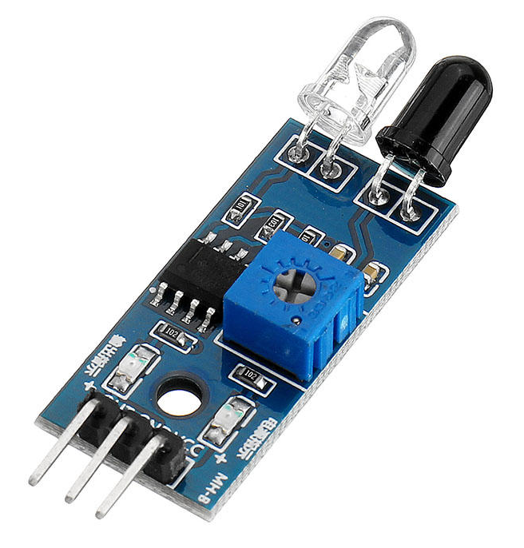

**INFRARED(IR) SENSOR**

**Definition for Sensors:**

***IR Sensor:***

An IR sensor is a device that detects and measure infrared radiation in its surrounding. It works by receiving and processing the heat radiation emitted or reflected by objects, allowing it to sense the presence, proximity or temperature of those objects without direct contact.

**Steps for program:**

Step 1: Start the program

Step 2: Initialize IR sensors and database

Step 3: Read IR sensor data and determine parking space occupancy

Step 4: Store sensor data and update parking space status

Step 5: User request parking information and display parking status on app/web

Step 6: Check if space is available and Reserve space if available

Step 7: IR sensor detects the vehicle and confirm entry

Step 8: Vehicle leaves the space and IR sensor detects space vacancy

Step 9: User end reservation and related reserved space

Step 10: Stop the program

**FLOWCHART:**

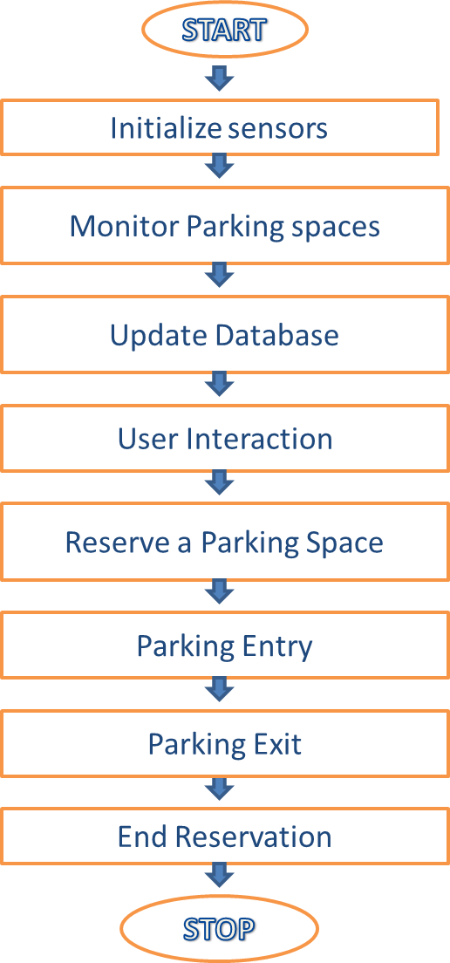

BLOCK DIAGRAM

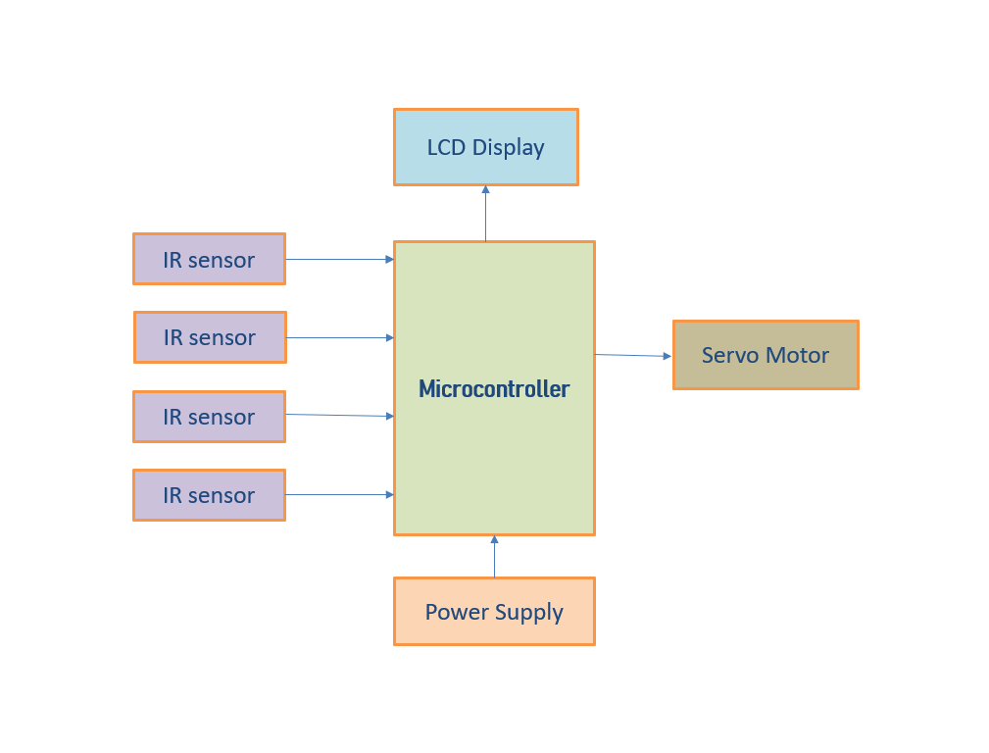

Block Diagram Description:

1. **Microcontroller:**

Central processing unit for a parking system.

Receives data from IR sensors and control the system’s operations.

1. **IR sensor:**

These Sensors are placed at each parking space to detect the presence of a vehicle. When a vehicle enters or leaves a parking space, the IR sensor sends a signal.

1. **Servo Motor:**

A Servo motor is a type of electric motor that is designed to provide precise control of angular position, velocity and acceleration.

1. **Power Supply:**

Indicate the power supply source and connections to all components that require power.

1. **LCD Display:**

LIQUID CRYSTAL DISPLAY(LCD) for displaying real time parking information to users.

**CIRCUIT DIAGRAM:**

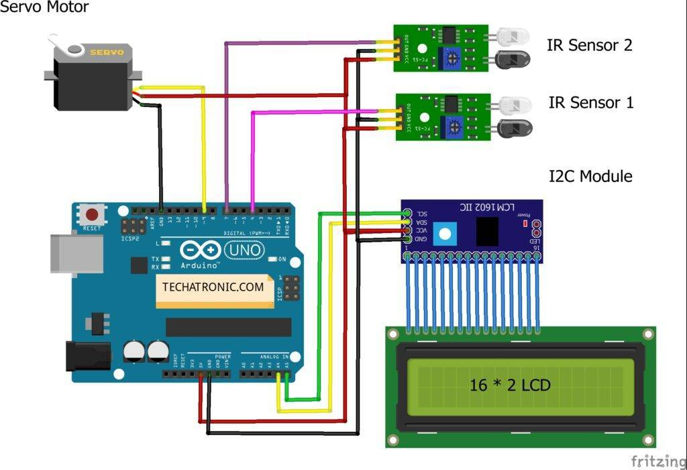

**APPLICATIONS:**

1. Real time parking Availability
2. Remote Monitoring and Management.